Graduation Project
Academic Year 2025-2026
Midyear Short Documentation

- Abstract
Skin diseases are among the most common health issues worldwide, yet early and accurate diagnosis remains challenging due to limited access to dermatologists and the visual similarity between many skin conditions. This project, Skinova, aims to handle this problem by providing an intelligent web-based diagnostic support system for patients.

The system allows users to upload images of affected skin areas, which are then analyzed using deep learning techniques to identify potential skin diseases. Based on the analysis results, the system provides general treatment recommendations while clearly emphasizing that it serves as a supportive tool rather than a replacement for professional medical diagnosis.

The motivation behind this project is to enhance early awareness, assist patients in understanding their skin conditions, and reduce unnecessary delays in Searching for medical advice. Skinova targets patients as its primary users, offering an accessible and user-friendly platform that combines artificial intelligence with healthcare services. The proposed solution leverages deep learning models trained on publicly available dermatological image datasets to extract visual features and perform disease classification.

By Integrating AI-based analysis with a web application, the project demonstrates the potential of intelligent systems in improving healthcare accessibility and supporting decision-making for patients.

  - Background :
Skin diseases represent a wide range of conditions affecting skin health, ranging from minor issues like simple rashes to more complex and dangerous conditions such as skin cancers. Globally, skin diseases are among the most prevalent health problems, affecting millions of people annually and leading to psychological and social impacts alongside physical health consequences. Diagnosing these conditions relies heavily on the clinical expertise of specialists; however, access to a qualified dermatologist is often difficult in certain regions, increasing the Probability of misdiagnosis or delayed treatment.

In recent years, there has been a growing interest in using Artificial Intelligence (AI) in healthcare to improve diagnostic quality and reduce pressure on health systems. Medical image processing and analysis techniques using AI models have proven highly effective in various fields, such as tumor diagnosis, radiographic analysis, and pathological pattern recognition. These methods allow for the exploration of visual patterns within medical data that may be invisible to the human eye, providing strong support for medical decision-making.

In In the context of dermatology, leveraging AI can provide auxiliary tools that help patients understand their health status faster, especially in the early stages of a disease. Intelligent systems can analyze skin images captured by users, compare patterns against large databases of pathological images, and then provide users with general recommendations regarding the potential condition and suggested treatments. These systems do not aim to replace doctors; rather, they provide diagnostic support to assist patients before consulting specialists.

Relying on online digital solutions can help bridge the gap between the increasing demand for healthcare and the insufficient availability of specialized doctors, particularly in resource-limited areas. Web-based systems offer quick and easy access without the need to install complex software.

The Skinova Graduation project emerges as part of these modern trends. It proposes the development of a web-based system that utilizes medical image processing and AI techniques to analyze patients' skin images and provide general treatment recommendations. These tools are expected to contribute to improving health awareness among users and providing primary support before a specialized medical consultation, thereby enhancing the efficiency of health services and helping to reduce misdiagnoses or unnecessary delays.

  - Problem definition :

Skin diseases constitute a significant global health concern due to their high prevalence, varied signs and symptoms, and potential physical and psychological impacts on patients. Despite their common nature, timely and accurate diagnosis of dermatological conditions remains a challenging task. One of the primary issues is the limited accessibility to dermatologists, which may arise from factors beyond financial constraints, such as geographical barriers, long waiting times, and the uneven distribution of specialized healthcare services. As a result, many patients experience delays in diagnosis or rely on self-assessment, which often leads to incorrect conclusions about their condition.

In addition to accessibility challenges, insufficient patient awareness plays a critical role in Inflaming the problem. Many individuals lack the necessary medical knowledge to differentiate between Harmless and serious skin conditions, causing them to either underestimate potentially dangerous symptoms or overreact to minor issues. This gap in awareness contributes to delayed medical consultation and, in some cases, the progression of preventable or manageable conditions into more dangerous stages. The impact of these challenges is particularly clear in resource-limited regions, where access to specialized dermatological care is more restricted and healthcare infrastructure may be insufficient to meet growing demand.

Although several digital health applications and online platforms have been developed to handle dermatological diagnosis, many existing solutions suffer from notable limitations. Some systems demonstrate limited diagnostic accuracy, while others require specialized devices or high-quality imaging equipment that may not be readily available to the general public. Additionally, a number of existing applications lack friendly user interfaces, reducing their usability and effectiveness for non-technical users

Furthermore, the absence of reliable Exploratory or initial pre-assessment tools places an additional load on healthcare systems and medical professionals. Many patients search for medical consultation for conditions that may not require immediate specialist involvement, while others delay visiting a dermatologist until symptoms worsen. This imbalance results in inefficient utilization of medical resources and increased pressure on already overloaded healthcare services. Without accessible tools that help patients perform an initial evaluation of their condition, healthcare systems continue to face challenges in prioritizing cases based on urgency. Consequently, there is a growing demand for intelligent supportive systems that can assist patients in understanding the severity of their condition, guide them toward appropriate next steps, and promote more effective communication between patients and healthcare provider.

To overcome these challenges, there is a clear need for an accessible and user-friendly system that can provide Initial diagnostic support and raise patient awareness without claiming to deliver final or crucial medical diagnoses. The Skinova project aims to fulfill this need by offering a web-based solution that analyzes skin images and provides general treatment recommendations. The system is designed to serve as an initial supportive tool rather than a conclusive diagnostic platform, assisting patients in making informed decisions and encouraging timely consultation with medical professional.

4. Related work:
Recent years have witnessed progress in the development of digital and AI-based solutions for dermatological analysis and skin disease assessment. Several research studies, mobile applications, and web-based platforms have been proposed with objectives similar to this project, However, despite their contributions, many existing implementations suffer from several limitations like limited diagnostic accuracy, issues with image size handling and lack flexibility in accepting images with varying resolutions or aspect ratios and limited diagnostic capabilities using AI the diagnostic process relies mainly on uploading the image and searching for visually similar images on the internet.

Implementation | Description
Modelderm | A web-based AI dermatology platform that provides image-based skin condition analysis with limited diagnosis capabilities general informational support, without treatment or medication management.
FirstDerm | Mainly Online dermatology consultation by board-certified dermatologists but has additional feature called AI-Powered Dermatology Search Engine, that just compares the uploaded photo with thousands of verified dermatology cases it uses a search engine for information retrieval using image matching
SkinScreen | decision support tool which provides immediate and meaningful access to skin lesion classification to support value-based healthcare goals
Skindetect AI | is an online skin disease analysis tool based on artificial intelligence. It can detect skin problems through AI technology

Main differences between them and our project :

Feature Implementation | Skinova  (our project) | Modelderm | FirstDerm | SkinScreen | Skindetect AI
Diagnosis | Ai-Based Full Diagnosis | Limited  /unspecified | Limited | Mostly Skin Cancer | Ai-Based Diagnosis
Treatment Recommendation | include treatment recommendation | unavailable | unavailable | unavailable | unavailable
Medical History for Past Diagnoses | Include medical history to track past skin disagnoses | unavailable | unavailable | unavailable | unavailable
Awareness Section include media like videos | Include Awareness Section | unavailable | unavailable | unavailable | unavailable
Exploring The Available Clinics and Pharmaces nearest to user based on Maps | Included | unavailable | unavailable | unavailable | unavailable

Project specifications:

- System Architecture :

The system adopts a three-tier architecture to ensure scalability, maintainability, and clear separation of responsibilities. The architecture consists of the presentation layer, application layer, and data layer, with the AI processing module integrated within the application layer.

The presentation layer represents the web-based user interface through which patients interact with the system. This layer provides functionalities such as user registration and authentication, image upload, result visualization, and access to general treatment recommendations. The interface is designed to be user-friendly and accessible across different devices

The application layer serves as the core processing unit of the system. It handles user requests, manages authentication logic, processes uploaded images, and coordinates communication between the user interface, database, and AI module. The integrated AI component performs image analysis and disease classification using trained models and returns diagnostic results along with general treatment recommendations.

The data layer is responsible for storing user information, uploaded images, system logs, and analysis results. This layer ensures secure data management and supports efficient retrieval for system operations and future analysis.

- Stakeholders :

- patients : The primary stakeholders of the Skinova system who use the platform to upload skin images, receive preliminary diagnostic support, and obtain general treatment recommendations. They are the main beneficiaries of the system’s service
- healthcare professionals : are Secondary stakeholders who may indirectly benefit from increased patient awareness and more informed medical consultation.

- Functional Requirements :

- The system shall allow users to create accounts and log in using secure authentication mechanisms
- The system shall enable users to upload skin images for analysis.
- The system shall validate uploaded images to ensure acceptable formats and quality.
- The system shall process uploaded images using AI models to identify potential skin conditions
- The system shall display the diagnostic results to users in a clear and understandable format.
- The system shall provide general treatment recommendations based on the analysis results.
- The system shall store user information and analysis history securely.
- The system shall allow users to view previous diagnoses and recommendations.

- NonFunctional Requirements :

    - The system should provide fast response times for image processing and result generation in few seconds
    - The system should ensure data security and protect user privacy, particularly for medical images and personal information
    - The system should be highly available and accessible through standard web browsers
    - The system should provide a user-friendly interface suitable for non-technical users
    - The system should support future expansion, such as adding new diseases or enhancing AI models.

- Entity Relationship Diagram (ERD) :

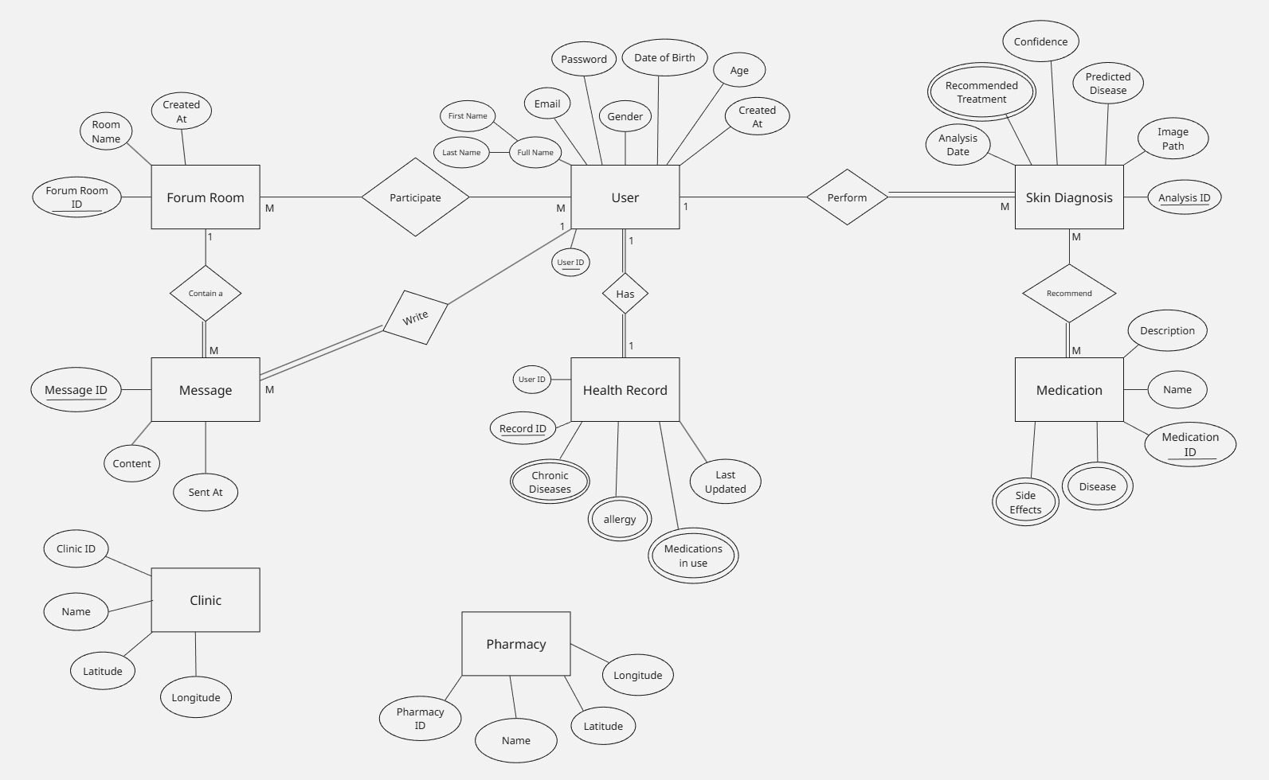

- AI Section :

The model was trained on the Massive Skin Disease Balanced Dataset.

We have used and explore three Model Architectures :

  - Custom CNN Model (HAM10000)

  - ResNet50 Transfer Learning Model

  - ConvNeXt Model

And in the end we selected ConvNeXT Model based on Accuracy and other
different metrics

to compare between them and choose the best one

- Dataset Description :

The model was trained on the Massive Skin Disease Balanced Dataset.

Class Diversity: 35 separate dermatological categories

Data Integrity:The dataset is strictly balanced to eliminate class-imbalance bias, preventing the model from favoring more common diseases and ensuring high sensitivity for rare conditions

- Methodology & Technical Framework

Data Preprocessing :

  - Spatial Standardization : Input images were resized to 150*150 pixels to maintain a balance between feature preservation and computational efficiency

  - Normalization: Pixel values were normalized to facilitate stable gradient flow and faster convergence .

  - Data Partitioning: A split of 80% for training and 20% for validation was employed to rigorously test the model’s ability to generalize to new cases

- Training Strategey & Fine Tuning :

To achieve peak diagnostic performance, a specialized Fine-Tuning approach was implemented :

  - Iterative Training (Epochs): The model underwent multiple training iterations (Epochs). Each cycle was meticulously monitored to adjust internal weights and minimize the error rate

  - Recursive Optimization: By repeating the training loops and fine-tuning the pre-trained weights, the model’s accuracy was progressively pushed beyond standard benchmarks .

  - Hyperparameter Tuning: During these cycles, learning rates and optimization parameters were adjusted to prevent overfitting while ensuring the model captured the subtle morphological differences in skin lesions

- Performance Evaluation & Results :

  - Overall Accuracy: 98.53%

  - Precision & Recall: Both reached 0.99, indicating an exceptional balance between identifying true positives and minimizing false alarms .

  - F1-Score: 0.99, confirming the model’s reliability across all 35 classes

2
- Work Plan:

Task | Task Title | Description | Task status  (completed/expected in time)
1 | Problem Identification | Conducted brainstorming sessions to identify a real-world problem related to skin diseases and healthcare accessibility | Completed
2 | System features and Services Identification | Identifing the core features and services of the proposed system | Completed
3 | Background Research and Literature Review | Studying existing systems, research papers, and applications related to skin disease analysis and AI-based healthcare solutions | Completed
4 | Dataset Collection and Preparation | Collected publicly available dermatological image datasets and performed initial preprocessing and organization | Completed
5 | AI Feature Selection and Extraction for AI Model | Identifing relevant visual features from dermatological images and analyzed suitable feature extraction approaches to improve model performance and classification accuracy. | Completed
6 | AI Model Evaluation Strategy | Defining evaluation metrics and validation strategies to assess the performance and reliability of the AI models, including accuracy analysis and errors | Completed
7 | Technology Stack Selection | Review the appropriate technologies, frameworks, and tools required for implementing the web application and AI components of the project | Completed
8 | Learning Required Technologies and Courses | Studing and followed relevant online courses and learning resources related to web development, databases, and AI techniques to support the implementation of the projec | Completed
9 | Web Application Development | Developing the web-based interface and backend services for image upload, processing, and result presentation | Expected in Time
10 | System Integration | Integrating the AI model with the web application to ensure smooth data flow and functionality | Expected in Time
11 | Testing and Evaluation | Testing the system for accuracy, performance, usability, and reliability under different scenarios | Expected in Time
12 | Documentation and Final Report | Preparing technical documentation, final report, and presentation materials for the graduation project | Expected in Time

